Hi Sujit,

I have decided my project to justify my search on

“ <http://www.zillow.com/zestimate/#acc>”

Project Title:

How Accurate is the House with Zestimates Vs Home price on Zillow for San Francisco, CA .

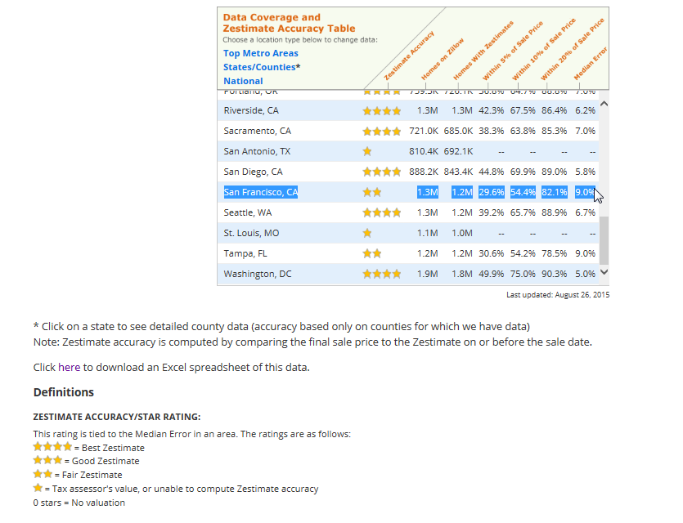

Goal:

My goal is to define Zestimate/STAR RATING is being justified as per this website (fair estimate as per this website.) or not.

Ideas:

1. Planning to treat Dependent variable as home value selling price and independent Variable as Home Zestimates.
2. Planning to see if there is any correlation between them.
3. My better option would be to do some simple linear regression analysis on the data set.